ELEC2004 Design Challenge Report

By Samuel Allpass (48030504) and Douglas Cowlishaw (4803121)

Black Box: 23

# Abstract

This reports investigates the design of a "white box" system to reverse the effects of an unknown "black box" that has a frequency-dependent signal response. The black box, a theoretical circuit with unknown internal components, alters input signals in a specific but undefined manner that differs depending on the frequency of the input waveform. The challenge is to design a white box that, when combined with the black box (ouput of black box provided to input of white box), restores the original input signal characteristics at the output. This problem mirrors real-world scenarios where systems must compensate for distortions or losses in communication, signal processing, and control systems.

The approach taken involves characterizing the black box by analysing its input-output behavior using a sinusoidal 1V signal. Using this data, key parameters such as frequency response, and nature (such as poles and zeroes) of the black filter are determined. These parameters will inform the design of the white box, which acts as an inverse filter to cancel out the black box’s effects such that

$$T_{bb}\left(jw\right)T_{wb}\left(jw\right)=1$$

Where $T(jw)$ are the transfer functions of the black box and white box respectively. Passive and active components, such as resistors, capacitors, and operational amplifiers, are used to construct two designs for the white box, depending on the exhibitedbehaviour of the black box.

Experimental validation is conducted by physically implementing the circuit on a breadboard and measuring the output using oscilloscopes and a waveform generator. The results demonstrate that while the white box still possess the wanted reversal characteristics, the white box was not entirely effective in restoring the original signal. Discussion is provided on the cause of the discrepancy between the expected and observed white/black box behavoiur. Improvements are suggested for future investigations that could improve the effectivness of such white box designs for this black box, as well as more complex white boxes to address more complex black box systems.

# 1.0 Introduction

After being presented with a black box unknown circuit system, it was requested that a circuit be designed that opposes the effects, such that when connected in series, the black box input should identically match that of the systems output. It was required that the system maintain this negation for the conditions that the input voltage and frequency are within ±10V and 0Hz to 20 000Hz respectively. The investigation first employed a frequency sweep to understand the potential components of the black box, utilising the poles and zeros observed in its bode plot to construct its transfer and further gain functions. Following this evaluation, mathematical transformations were conducted to quantify components to a potential filter solution, the gain function of which that negates that of the black box. Additionally, after constructing the calculated circuit, performing a secondary frequency sweep on the complete system allowed for the refinement of the solution design, and further validate the reports aim.

# 1.1 Background

Frequency response and Bode plots

In order to propose a circuit solution, which when connected, negates the gain of the black box, it was important to understand how the black box gain changes across a spectrum of frequencies. The most effective way to depict this data is through a bode plot. For a time-invariant linear system, bode plots prove an effective method of understanding a systems frequency response, plotting a semi-logarithmic plot between the gain and frequency (rohde-schwarz, n.d.).

For an unidentified system, its corresponding bode plot can be determined by measuring the voltage output at each point of a frequency sweep, throughout which it is crucial that the peak-to-peak voltage input remains constant. With given frequency and output voltage measurements, the corresponding frequency values and gain can be calculated as follows:

$$Gain \left(dB\right)=\left|G\left(s\right)\right|=20\log_{10}\left|\frac{V_{out}}{V_{in}}\right|=20\log_{10}{|H\left(s\right)|}$$

Where H(s) is the transfer function of the black box, and $s=jw_{rad/s}$ for simplicity.

$$Frequency_{rad/s}= f_{Hz}*2π$$

In order to determine a circuit solution which forms a gain that negates the frequency dependence of the black box, it is necessary to evaluate aspects of the black box bode plot. Any unknown circuit produces a transfer function $H(s)$, such that the input $N(s)$ and output $D\left(s\right)$ voltages can be related as follows:

$$H\left(s\right)=\frac{D(s)}{N(s)}$$

Such a transfer function would produce two interesting aspects, zeros, frequency solutions at which $D\left(s\right)=0$, and poles, frequencies at which $N(s)$ = 0. The cutoff frequencies at which either a zero or pole occur, result in noticeable changes in the gradient of the bode plot. Given the gain follows:

$$\left|G\left(s\right)\right|=20\log_{10}\left|\frac{D\left(s\right)}{N\left(s\right)}\right|=20\log_{10}\left|D\left(s\right)\right|-20\log_{10}\left|N\left(s\right)\right|$$

It becomes clear that for a given cutoff frequency, a pole would in a gradient change of -20dB/decade, and similarly, 20dB/decade for zeros. As such, identifying the number of poles and zeros of the black box bode plot would indicate not only the type of circuit present, but also an estimate on the configuration required to produce the inverse the gain function.

Following the development of the black box bode plot, The transfer function values can be constructed utilising known cutoff frequency values as follows. The general transfer function for any circuit presents the form:

$$H\left(s\right)=\frac{D(s)}{N(s)}=K∏\frac{(s-a_{n})}{(s-b_{n})}$$

Where $a_{n} and b$ are the break frequencies observed on the bode plot for the zeros and poles respectively. Furthermore, the transfer function to the solution circuit (wb) should follow:

$$H_{wb}\left(s\right)=H_{bb}{\left(s\right)}^{-1}= K∏\frac{(s-a_{n})}{(s-b_{n})}$$

And thus follows the gain function:

$$\left|G_{wb}\left(s\right)\right|=20\log\left|K∏\frac{\left(s-a_{n}\right)}{\left(s-b_{n}\right)}\right|=20\log\left(K∏\frac{\sqrt{\left(s^{2}-a_{n}^{2}\right)}}{\sqrt{\left(s^{2}-b_{n}^{2}\right)}}\right)$$

Filter design

In order to design a filter that negates the effects of the black box, it must first be understood which filters prove effective for the given case. Fundamental first order filters fall into four categories, these being, low-pass, high-pass, band-pass and band-stop filters. 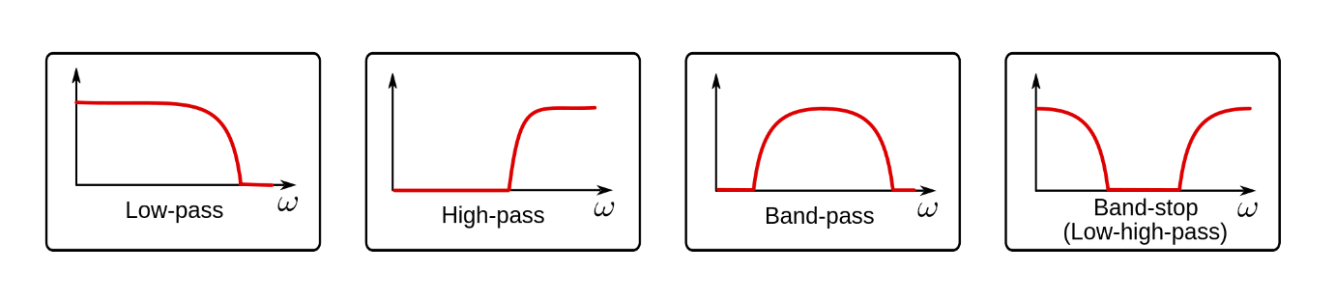

Figure 1: First order frequency filters bode plot forms (SmartCitizen, 2017).

The filters observed in figure 1 consist of key cutoff frequency locations, points at which the gradient of the bode plot changes considerably. Importantly, it is vital to recognise that the cutoff frequency refers to the gain at which it is 3dB above or below the flattening of the bode plot for a zero or pole respectively. By identifying the pole and zero positions of the given bode plot, it becomes apparent as to the type of filter observed, and subsequently the filter required to negate the effects. It is significant to recognise that the number of poles within the circuit relates to the number of energy storing components of the circuit, and so the circuit form of the black box or solution filter can be further estimated.

However, not all filters follow the first order form, such that more complex circuit design is required to negate the black box effects. The construction of complex systems becomes manageable when primarily focusing on the cutoff frequencies of the bode plot, such that following the same transfer function translations previously outlined, by identifying the poles and zeros, the values of a solution circuit could be mathematically determined.

Despite a circuit design successfully negating the frequency response of the black box, it is often the case that the constant peak-to-peak voltage observed on the solution output may differ in magnitude from the input voltage due to inherent losses in passive components such as resistors, capacitors and inductors. As such, it is often necessary to employ an active circuit design, introducing an operation amplifier to increase or decrease the output voltage as desired. As observed in figure 2, optimising the component values within the op-amp, the output of the solution circuit, $V_{i}$, can be adjusted to match that of the black box input, such that $V_{bb input}=V_{op-amp output}$. Further, in creating a solution circuit, it must be additionally verified that the chosen op-amp includes DC terminals that accommodate 10V, such that all voltages within the required ±10V peak-to-peak black box input range can be appropriately returned without incidental voltage flatlines at the limits. Additionally, the slew rate of the op-amp, the rate at which an op-amp can change its voltage per unit time, must be considered when during the selection process in an attempt to produce an accurate voltage output for frequencies up to 20000Hz as is requested.

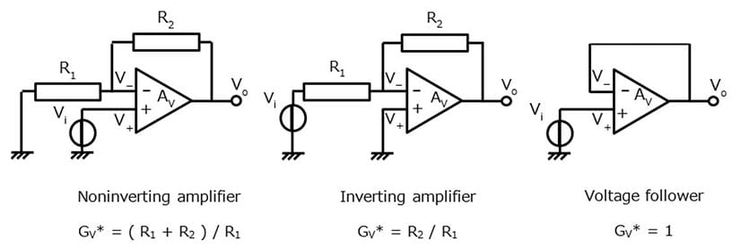

Figure 2: Noninverting, inverting and voltage following operational amplifiers general forms (Toshiba, n.d.).

# 1.2 Experimental Results

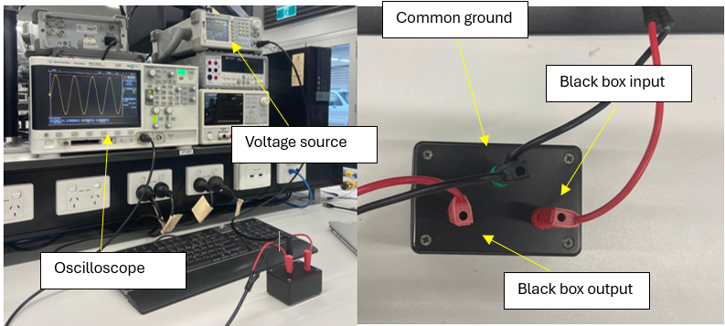

Figure 3: Experimental setup of black box frequency sweep. The left half identifies the voltage source and oscilloscope, with the right side indicating the configuration of the black box.

In order to accurately perform a frequency sweep on the black box circuit, the following setup was employed as depicted in figure 3. A sine wave voltage source set to a constant 1V peak-to-peak was connected to the input black box terminal and common ground. Further, an oscilloscope was connected in order to measure the potential difference between the black box output and the common ground. The oscilloscope peak-to-peak voltage was then measured over a 1 to 20000Hz domain with intervals as small as 1Hz surrounding identified poles and zeros.

Following the frequency sweep, the bode plot observed in figure 4 was constructed, noting that the frequency of the voltage source was to be converted to rad/s.

Figure 4: Black box bode plot constucted from experimental data.

In order to quantify the gain observed in figure 4, it was first recognised that the black box consisted of a circuit with one pole and one zero, as apparent by the two major shifts in gradient. Importantly, it was recognised that the gradient of the bode plot changed by 20dB/dec at each pole and zero, an apparent property of a first order circuit as previously discussed. As such it was understood that the black box modelled that of a first order high-pass filter, and so following the form was expected.

$$H_{bb}\left(s\right)=K*\frac{s-a}{s-b}$$

Where a and b are the two cutoff frequencies observed for the zero and pole respectively. To solve for the values of K, a and b, it was first decided to investigate the gain as the frequency approached the highest measured values. As is evident in the figure, as the frequency of the input voltage was increased, the gain clearly approached 0, such as to say:

$$\lim_{w→∞}{20\log_{10}\left|H_{bb}\left(w\right)\right|=0} and thus \lim_{w→∞}{|H_{bb}\left(w\right)|}={10}^{0}=1$$

As a result, the following conclusion was drawn about the transfer function:

$$\lim_{w→∞}\left|H_{bb}\left(w\right)\right|= \lim_{w→∞}{k*\frac{\sqrt{w^{2}+a^{2}}}{\sqrt{w^{2}+b^{2}}}=k=1}$$

In order to quantify the values of a and b, it was justified that the frequency at which the gain was three decibels below the upper limit, such that the gradient was decreased by 20dB/decade would correspond to the pole. This finding indicate that the pole frequency of the black box was 2550 rad/s as the corresponding gain was -3dB.

Similarly, the frequency at which the gain was three decibels above that of its minimum gain, corresponds to the black box zero frequency as the gradient was increased by 20dB/decade. As such, the frequency at which the gain was -8.8dB is observed to be 741 rad/s. Given the values of k, a and b were determined, the final transfer, and further gain function were constructed.

$$H_{bb}\left(s\right)=\frac{s-741}{s-2550} such that G\left(s\right)=20\log_{10}\left(\frac{\sqrt{s^{2}+{741}^{2}}}{\sqrt{s^{2}+{2550}^{2}}}\right)$$

2.0 Solution

The goal of this investigation is to develop a ‘white box’ circuit to reverse the effects of a given black box. In operation, this task requires that when a given input signal $V_{i}$ is sent into the black box, and the corresponding black box output signal is sent into the designed ‘white box’, the output signal should match the original input signal $V_{i}$. In order to determine and validate this white box design, the following process was followed:

1. The frequency response of the black box was analysed using a frequency sweep and the transfer function $T_{bb}(jw)$ was determined.
2. The transfer function $T_{wb}(jw)$ of the needed white box was experimentally determined in order to reverse the effects of the black box such that for a given input signal, $T_{bb}\left(jw\right)T_{wb}\left(jw\right)=1$.
3. A suitable circuit was designed that had the required transfer function $T_{wb}(jw)$.
4. The frequency response of black box and white box were analysed using a frequency sweep to determine the effectiveness of the designed white box.

The procedures, calculations and results of part of this process is outlined in greater detail in this section.

2.1 – Black Box Analysis

2.2 – White Box Design

2.2.1 – White Box Transfer Function

The analysis of the black box filter yielded a high pass filter with transfer function:

$$T_{bb}\left(s\right)=\frac{s+741}{s+2550}$$

To reverse the effects of the black box such that $V_{in}=V_{out}$, the white box’s transfer function must be the inverse of the black box transfer function such that:

$$T_{bb}\left(s\right)T_{wb}\left(s\right)=1$$

Hence, the transfer function of the white box must be a filter of the form:

$$T_{wb}={\left(T_{bb}\left(s\right)\right)}^{-1}=\frac{s+2550}{s+741}$$

This white box transfer function yields three main conditions for the circuit of the white box:

1. The white box must be a low pass filter
2. The white box must have one pole at $w=741 rad/s$ and one zero at $w=2550 rad/s$
3. The white box must have a $K$ value equal to one to preserve the amplitude of the input voltage.

Hence, it is clear the white box must be some kind of low pass active filter. To achieve this transfer function, two main white box designs were proposed and considered.

Before designing a low pass filter with this transfer function, several important factors must be considered. The white box transfer function is clearly a filter with one pole and one zero like the black box. However, in order to combat the high pass, the white box filter must be a low pass filter so that the higher frequency domination is levelled. However, this low pass filtering will necessarily introduce a $K$ value less than one (if passive filters are used), meaning the final output voltage is extremely weak. In order to bring the amplitude of the output voltage back to the input voltage, an amplifier (such as an operational amplifier) of some kind must be used.

Hence, the white box design will be an active low pass filter, in the form of a low pass filter followed by an operational amplifier.

2.2.2 – Design 1: Dual Op-Amp

The first design to be considered was an active low-pass operation amplifier filter combined with an inverting unity gain operation amplifier as shown below:

Figure : General from for active low-pass filter combined with inverting unity gain op-amp.

In this design, the low pass filtering with $K=1$ is achieved using an op-amp active filter with two resistors of different value and two capacitors of the same value, followed by another inverting op-amp that flips sign of the waveform to the original with a unity gain. This design was the first to be considered as the active filter design preserved the unity $K$ value along with the low-pass filtering required using one pole and one zero (provided by the parallel resistors and capacitors). The derivation of the transfer function of this filter is shown below:

$$Let Z_{1}=C||R_{1}={\left(jwC+\frac{1}{R_{1}}\right)}^{-1}=\frac{R_{1}}{1+R_{1}jwC}$$

$$Let Z_{2}=C||R_{2}=…=\frac{R_{2}}{1+R_{2}jwC}$$

As $V_{-}=V_{+}$, and no current feeds enters the negative terminal of the op-amp by ideal assumptions

$$\frac{V_{in}-0}{Z_{1}}=\frac{{0-V}_{a}}{Z_{2}}$$

The second om-amp design inverts the signal, meaning $V_{out}= -V_{a}$. Hence,

$$\frac{V_{in}}{Z_{1}}=\frac{V_{out}}{Z_{2}}$$

$$\frac{V_{out}}{V_{in}}=\frac{Z_{2}}{Z_{1}}$$

$$T\left(jw\right)=\frac{R_{2}(1+R_{1}Cjw)}{R_{1}(1+R_{2}Cjw)}$$

$$T\left(s\right)=\frac{\frac{1}{R_{1}C}+s}{\frac{1}{R_{2}C}+s}$$

The values of R1, R2 and C could then be adjusted to match the pole and zero values needed for the transfer function.

2.2.2 – Design 2: Passive Filter with Non-Inverting Op-Amp

The second design to be considered was using a passive low-pass filter with one pole and one zero combined with a non-inverting amplifier to amplify the reduced output to one, shown below:

Figure : General form of a passive low-pass filter with non-inverting op-amp.

This design uses a passive filter to provide the low-pass function. However, since it is a passive filter, it introduces a $K$ value less than one, leading to a weaker output signal. To compensate for this loss, a non-inverting amplifier is included in the design. This amplifier boosts the attenuated output signal, restoring it to the original input voltage level as required by the task. As a result, the final design combines a passive low-pass filter with one pole and one zero, followed by an operational amplifier to maintain the desired output. The derivation of the transfer function is shown below:

By voltage divider: $$V_{a}=V_{in}\frac{R_{2}+\frac{1}{jwC}}{R_{1}+R_{2}+\frac{1}{jwC}}$$

$$\frac{V_{a}}{V_{in}}=\frac{jwCR_{2}+1}{jwC\left(R_{1}+R_{2}\right)+1}$$

$$\frac{V_{a}}{V_{in}}=\frac{R_{2}}{(R_{1}+R_{2})}\frac{jw+\frac{1}{CR_{2}}}{jw+\frac{1}{C(R_{1}+R_{2})}}$$

Op-amp is in non-inverting configuration, meaning:

$$\frac{V_{out}}{V_{a}}=1+\frac{R_{4}}{R_{3}}$$

Multiplying this expression on both sides of the previous equation:

$$\frac{V_{out}}{V_{in}}=\left(1+\frac{R_{4}}{R_{3}}\right)\frac{R_{2}}{(R_{1}+R_{2})}\frac{jw+\frac{1}{CR_{2}}}{jw+\frac{1}{C(R_{1}+R_{2})}}$$

The values of R1, R2 and C could be adjusted to match the required pole and zero of the white box transfer function, and the value of R4 and R3 to reverse the loss incurred by the passive part of this filter (to ensure $K=1$).

2.2.3 – Final Solution Design

While both designs considered can achieve the needed white box transfer function, they have differing properties that affect their usefulness for this task.

Both designs rely on operational amplifiers, which have limitations as described in the background theory. The available amplifiers to use are the LM741 operational amplifiers. The DC Input Voltages for the LM741 are 15V, far above the input waveform amplitude for this task of 10V bounded by the black box. The operating temperatures and slew rates of this component is also well within the conditions present in this task. Thus, both designs are suitable and would have minimal distortion from the effects of operational amplifiers.

While design 1 has a relatively simpler transfer function, not requiring a separate component calculation for the amplitude gain, it also uses two operational amplifiers as opposed to just one, which increases the risk of failure and increases the complexity of the circuit wiring. Furthermore, it also needs 6 resistor/capacitor components, increasing the overall potential for component value manufacturing error.

While design 2’s transfer function seems more complex, the circuit design itself is much simpler than design 1. Only 5 resistor/capacitor components are needed and only one operational amplifier. Hence, it would be marginally cheaper and slightly reduce error that could be introduced from circuit components and DC power supply.

Hence, while both solutions satisfy all the requirement for the needed transfer function, **design 2** will be used and tested as the white box for this system.

2.2.4 – Component Calculations

To ensure the transfer function of the white box matches the needed transfer function, the resistance and capacitance values must be calculated and chosen correctly. In the laboratory, there were limited choices of values to use, and particularly limited values of capacitors. As a base component, a 0.47uF capacitor was chosen to be used. From this, the values of R1 and R2 can be calculated to match the required zero and pole:

$$\frac{1}{CR_{2}}=2550$$

$$R_{2}=\frac{1}{2550C}=834.4Ω$$

$$\frac{1}{C{(R}_{1}+R_{2})}=741$$

$$\frac{1}{741C}=R_{1}+R_{2}$$

$$R_{1}=\frac{1}{741C}-R_{2}=2037Ω$$

The loss from the passive low pass filter is thus:

$$\frac{R_{2}}{R_{1}+R_{2}}=\frac{834.4}{834.4+2037}=0.29$$

Hence to bring the overall $K$ value back up to one, we have:

$$0.29\left(1+\frac{R_{4}}{R_{3}}\right)=1$$

$$\frac{R_{4}}{R_{3}}=2.45$$

Hence R4 and R3 can be any resistor values provided they form that ratio. Resistors of 1100 $Ω$ and 2700 $Ω$ were chosen as these were available in the lab. Note that the way the other resistor values were achieved are discussed in the next section. The final white box design, with correct components is:

Figure : Final white box design circuit diagram

2.3 – Testing White Box Design

To verify the effectiveness of the white box design, the designed circuit was constructed in the laboratory with the following methodology:

1. The needed resistor values were obtained as follows:

* 834 = 800 + 10 + 15
* 2037 = 2000 + 20 + 20
* 1100 = 1000 +100
* 2700 = 2700

1. With these resistors, the 0.47uf capacitor and an LM741 op-amp, the white box circuit was constructed as shown in figure 7.
2. The black box was setup as described in section 1.2 with an input 1V sinusoidal waveform, except with the output terminal connected to the input terminal of the white box.
3. The +15V and -15V terminals of the op-amp were connected from the DC power sources provided, and oscilloscope probes were set up across the input terminal of the black box and ground, as well as the output terminal of the white box and ground.
4. A frequency sweep was conducted from 1Hz to 20kHz using the 1V sinusoidal waveform, and the gain of the output waveform was recorded using a bode plot.

Recall that if the white box worked as intended, the gain across the entire frequency sweep should remain zero, meaning the input voltage is the same as the output voltage. The bode plot obtained, as well as the experimental setup is shown below:

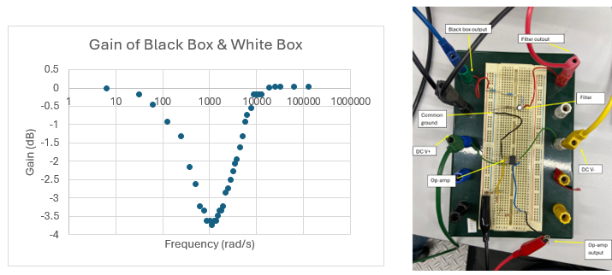

Figure : Bode plot of black box and white box connected in series (left) as displayed in experimental setup (right).

3.0 – Discussion

3.1 – Effectiveness of Solution

In any real-world investigation, there are always numerous sources of error that lead to the experimental results deviating from the theory. Clearly, the results from the bode plot show the white box filter did not obtain a perfect reversing of the black box signal. Instead, a band-stop filter was observed, which had a minimum gain of (-3.75dB) at 1130 rad/s. At both extremely high and extremely low frequencies, the expected result was observed, with a gain of approximately zero.

Hence, while the white box demonstrated the desired effects of low-pass filtering and raising the amplitude using an active component, the precision of the components was clearly not accurate for its design.

3.2 – Limitations in Design

There were two significant limitations in the design which these errors can be attributed to. The first is that the transfer function derived using the black box frequency response relied on the 3dB assumption for determining the pole and the zero. While this assumption is accurate, it is only an approximation which is made by considering the limiting response at low frequencies, at high frequencies and assuming a linear response in between. Hence, the calculated black box transfer function was likely not entirely accurate. This result can be clearly seen when the theoretical transfer function magnitude is graphed alongside the data:

Figure 9: Black box bode plot with mathematically calculated gain function.

In particular, the transfer function becomes increasingly inaccurate on the slope at points lower than 1100, which corresponds approximately to the band stop observed. Hence, the component values calculated that are based on the needed white box transfer function are likely to be inaccurate.

Furthermore, the resistor values used in the final circuit did match exactly with the calculations, being off by up to 5 ohms. This deviation could be responsible for the inability of the white box to reverse the effects of the black box during the slope between pole and zero. Additionally, the manufacturing error present on each component, while small, would have also contributed to the error.

3.3 – Improvements

To improve the effectiveness of the white box design, several improvements can be made. To improve the design, a more rigorous method of determining the black box transfer function should be used. Verifying the transfer function derived by using more limiting cases, or even techniques such as non-linear regression should be used to obtain more accurate pole and zero values. In fact, this technique was used after the white box was tested, and it yielded a transfer function of:

$$T\left(s\right)=\frac{s+709.914}{s+2745.9}$$

This transfer function was again graphed alongside the data, and was found to be a much more accurate transfer function, as seen below:

Figure : Black box bode plot with gain function constructed using a non-linear regression method (Desmos).

If the black box transfer function obtained is more correct, the needed white box transfer function would be more accurate, meaning that the calculated resistance values will be more accurate, and the white box would be more effective.

Within the experimental method, using resistor values that exactly match with calculations by buying custom made resistors or using a laboratory that has a larger collection of resistor values would increase the accuracy of the white box. Finally, using other possible white box designs that are active low pass filters with the required pole and zero (such as design 1 considered in this report) could yield a more effective white box, and should be tested.

If these improvements are made, a more accurate white box can be developed that better solves the problem this investigation poses.

# Conclusion

The conducted investigation aimed at determining a circuit design that negates the effects of the frequency responding black box. After conducting a frequency sweep on the black box, it was observed that the circuit resembled that of a high pass filter, with one zero and one pole occurring at 741rad/s and 2550rad/s respectively. As a result, the transfer function was found to be $H_{bb}\left(s\right)=\frac{s-741}{s-2550}$ and so follows the white box design transfer function of $H_{wb}\left(s\right)=\frac{s-2550}{s-741}$. Mathematically, this reasoned that the corresponding low pass filter could be constructed using a first order RC circuit with a 0.47uF capacitor, $R_{1} and R_{2}$ values of 1957Ω and 750Ω, and a corresponding operational amplifier with $R_{f} and R_{s}$ values of 2700Ω and 1000 Ω to correct the output peak-to-peak voltage to that of the black box input. Despite these calculations, a secondary frequency sweep of the total solution identified that the low pass filter and operation amplifier with $C=0.47uF, R_{1}=2037Ω, R_{2}=834Ω and \frac{R_{f}}{R_{s}} ratio of 2.45$ respectively prove far superior in achieving the reports aim.

# References

The Asymptotic Bode Diagram: Derivation of Approximations. (n.d.). Cache://lpsa.swarthmore.edu/Bode/BodeHow.html - Google search. <https://lpsa.swarthmore.edu/Bode/BodeHow.html>

Rohde & Schwarz GmbH & Co KG. (n.d.). Understanding bode plots. Industry-leading technology company | Rohde & Schwarz. <https://www.rohde-schwarz.com/au/products/test-and-measurement/essentials-test-equipment/digital-oscilloscopes/understanding-bode-plots_254514.html>

SmartCitizen. (2017, December 4). About filters and convolution - Signal processing for audio part IV. Smart Citizen. <https://forum.smartcitizen.me/t/about-filters-and-convolution-signal-processing-for-audio-part-iv/945>

Texas Instruments. (n.d.). LM741 Operational Amplifier. Analog | Embedded processing | Semiconductor company | TI.com. <https://www.ti.com/lit/ds/symlink/lm741.pdf>

Toshiba. (n.d.). What is an operational amplifier? | Toshiba electronic devices & storage Corporation | Europe(EMEA). Top Page | Toshiba Electronic Devices & Storage Corporation | Americas – United States. <https://toshiba.semicon-storage.com/eu/semiconductor/knowledge/faq/linear_opamp/what-is-an-operational-amplifier.html>